### [**04 - Iteration Control Structures**](https://www.rajalakshmicolleges.net/moodle/course/view.php?id=84#section-4)

**Ex. No. : 4.1 Date:30/3/24**

**Register No.: 231501015 Name: Aniruth S V**

[**Factors of a number**](https://www.rajalakshmicolleges.net/moodle/mod/quiz/view.php?id=5720)

Determine the factors of a number (i.e., all positive integer values that evenly divide into a number).

**For example:**

| **Input** | **Result** |
| --- | --- |
| 20 | 1 2 4 5 10 20 |

**Program:**

num=int(input())

i=1

while(i<=num):

if(num%i==0):

print(i,end=” “)

i+=1

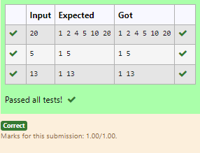**Output:**

**Ex. No. : 4.2 Date:30/3/24**

**Register No.: 231501015 Name: Aniruth S V**

[**Non**](https://www.rajalakshmicolleges.net/moodle/mod/quiz/view.php?id=5717) **Repeated Digit Count**

Write a program to find the count of non-repeated digits in a given number N. The number will be passed to the program as an input of type int.

Assumption: The input number will be a positive integer number >= 1 and <= 25000.

Some examples are as below.

If the given number is 292, the program should return 1 because there is only 1 non-­repeated digit '9' in this number

If the given number is 1015, the program should return 2 because there are 2 non-repeated digits in this number, '0', and '5'.

If the given number is 108, the program should return 3 because there are 3 non-­repeated digits in this number, '1', '0', and '8'.

If the given number is 22, the function should return 0 because there are NO non-­repeated digits in this number.

**For example:**

| **Input** | **Result** |
| --- | --- |
| 292 | 1 |
| 1015 | 2 |
| 108 | 3 |
| 22 | 0 |

**Program:**

num=int(input())

count=0

last=len(str(num))

for i in range(1,last):

temp=num%10

num=num//10

if (str(temp)not in str(num)):

count+=1

if(len(str(num))==1 and count==last-1):

print(count+1)

else:

print(count)

**Output:**

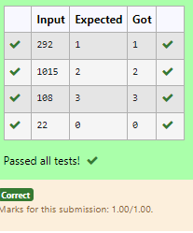

**Ex. No. : 4.3 Date:30/3/24**

**Register No.: 231501015 Name: Aniruth S V**

**Prime Checking**

Write a program that finds whether the given number N is Prime or not. If the number is prime, the program should return 2 else it must return 1.

Assumption: 2 <= N <=5000, where N is the given number.

Example1: if the given number N is 7, the method must return 2

Example2: if the given number N is 10, the method must return 1

**For example:**

| **Input** | **Result** |
| --- | --- |
| 7 | 2 |
| 10 | 1 |

**Program:**

a=int(input())

count=0

for i in range(2,a):

if (a%i==0):

count+=1

if(count==0):

print(“2”)

else:

print(“1”)

**Output:**

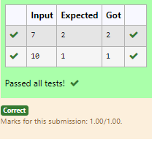

**Ex. No. : 4.4 Date:30/3/24**

**Register No.: 231501015 Name: Aniruth S V**

**Next Perfect Square**

Given a number N, find the next perfect square greater than N.

Input Format:

Integer input from stdin.

Output Format:

Perfect square greater than N.

Example Input:

10

Output:

16

**Program:**

from math import sqrt

num=int(input())

while True:

a=int(sqrt(num))

if(num==pow(a,2)):

print(num)

break

else:

num+=1

**Output:**

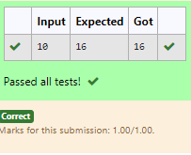

**Ex. No. : 4.5 Date:30/3/24**

**Register No.: 231501015 Name: Aniruth S V**

**Nth Fibonacci**

Write a [program](https://www.rajalakshmicolleges.net/moodle/mod/quiz/view.php?id=3478) to return the nth number in the fibonacci series. The value of N will be passed to the [program](https://www.rajalakshmicolleges.net/moodle/mod/quiz/view.php?id=3478) as input.

NOTE: Fibonacci series looks like –

0, 1, 1, 2, 3, 5, 8, 13, 21, 34, 55, . . . and so on.

i.e., Fibonacci series starts with 0 and 1, and continues generating the next number as the sum of the previous two numbers.

• first Fibonacci number is 0,

• second Fibonacci number is 1,

• third Fibonacci number is 1,

• fourth Fibonacci number is 2,

• fifth Fibonacci number is 3,

• sixth Fibonacci number is 5,

• seventh Fibonacci number is 8, and so on.

**For example:**

**Input:**

**7**

**Output**

**8**

**Program:**

a=int(input())

b=0

c=1

d=0

for i in range(3,a+1):

d=c+b

b=c

c=d

print(d)

**Output:**

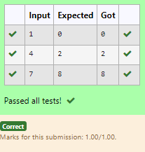

**Ex. No. : 4.6 Date:30/3/24**

**Register No.: 231501015 Name: Aniruth S V**

**Disarium Number**

A Number is said to be Disarium number when the sum of its digit raised to the power of their respective positions becomes equal to the number itself. Write a [program](https://www.rajalakshmicolleges.net/moodle/mod/quiz/view.php?id=3478) to print number is Disarium or not.

Input Format:

Single Integer Input from stdin.

Output Format:

Yes or No.

Example Input:

175

Output:

Yes

Explanation

1^1 + 7^2 +5^3 = 175

Example Input:

123

Output:

No

**For Example:**

| **Input** |  | **Result** |
| --- | --- | --- |
| 175 |  | Yes |
| 123 |  | No |

**Program:**

num=int(input())

last=len(str(num))

temp=num

Sum=0

for i in range(0,last):

n=temp%10

temp=temp//10

sum=sum+(pow(n,last-i))

if (sum==num):

print(“Yes”)

else:

print(“No”)

**Output:**

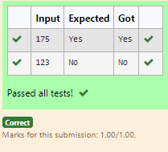

**Ex. No. : 4.7 Date:30/3/24**

**Register No.: 231501015 Name: Aniruth S V**

**Sum of Series**

Write a program to find the sum of the series 1 +11 + 111 + 1111 + . . . + n terms (n will be given as input from the user and sum will be the output)

Sample Test Cases

Test Case 1

Input

4

Output

1234

Explanation:

as input is 4, have to take 4 terms.

1 + 11 + 111 + 1111

Test Case 2

Input

6

Output

123456

**For example:**

| **Input** | **Result** |
| --- | --- |
| 3 | 123 |

**Program:**

num=int(input())

sum1=0

for i in range(1,num+1):

st=’1’*i

sum1=sum1+int(st)

print(sum1)

**Output:**

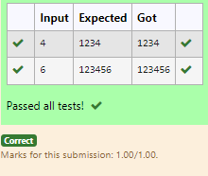

**Ex. No. : 4.8 Date:30/3/24**

**Register No.: 231501015 Name: Aniruth S V**

**Unique Digit Count**

Write a program to find the count of unique digits in a given number N. The number will be passed to the program as an input of type int.

Assumption: The input number will be a positive integer number >= 1 and <= 25000.

For e.g.

If the given number is 292, the program should return 2 because there are only 2 unique digits '2' and '9' in this number

If the given number is 1015, the program should return 3 because there are 3 unique digits in this number, '1', '0', and '5'.

**For example:**

| **Input** | **Result** |
| --- | --- |
| 292 | 2 |
| 1015 | 3 |

**Program:**

num=int(input())

count=0

last=len(str(num))

for i in range(1,last):

n=num%10

num=num//10

if (str(n)not in str(num)):

count+=1

print(count+1)

**Output:**

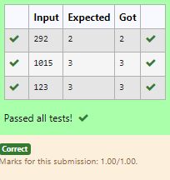

**Ex. No. : 4.9 Date:30/3/24**

**Register No.: 231501015 Name: Aniruth S V**

**Product of single digit**

Given a positive integer N, check whether it can be represented as a product of single digit numbers.

Input Format:

Single Integer input.

Output Format:

Output displays Yes if condition satisfies else prints No.

Example Input:

14

Output:

Yes

Example Input:

13

Output:

No

**Program:**

a=int(input())

count=0

for i in range(1,10):

for j in range(1,10):

if (i*j==a):

print(“Yes”)

count+=1

break

if(count>0):

break

if(count==0):

print(“No”)

**Output:**

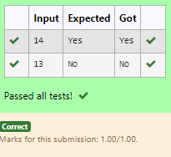

**Ex. No. : 4.10 Date:30/3/24**

**Register No.: 231501015 Name: Aniruth S V**

**Perfect Square After adding One**

Given an integer N, check whether N the given number can be made a perfect square after adding 1 to it.

Input Format:

Single integer input.

Output Format:

Yes or No.

Example Input:

24

Output:

Yes

Example Input:

26

Output:

No

**For example:**

| **Input** | **Result** |
| --- | --- |
| 24 | Yes |

**Program:**

from math import sqrt

num=int(input())

fin=num+1

sq=int(sqrt(fin))

if (fin==pow(sq,2)):

print(“Yes”)

else:

print(“No”)

**Output:**

